**14.E - COMMERCE SYSTEM**

1. **USE CASE DIAGRAM**

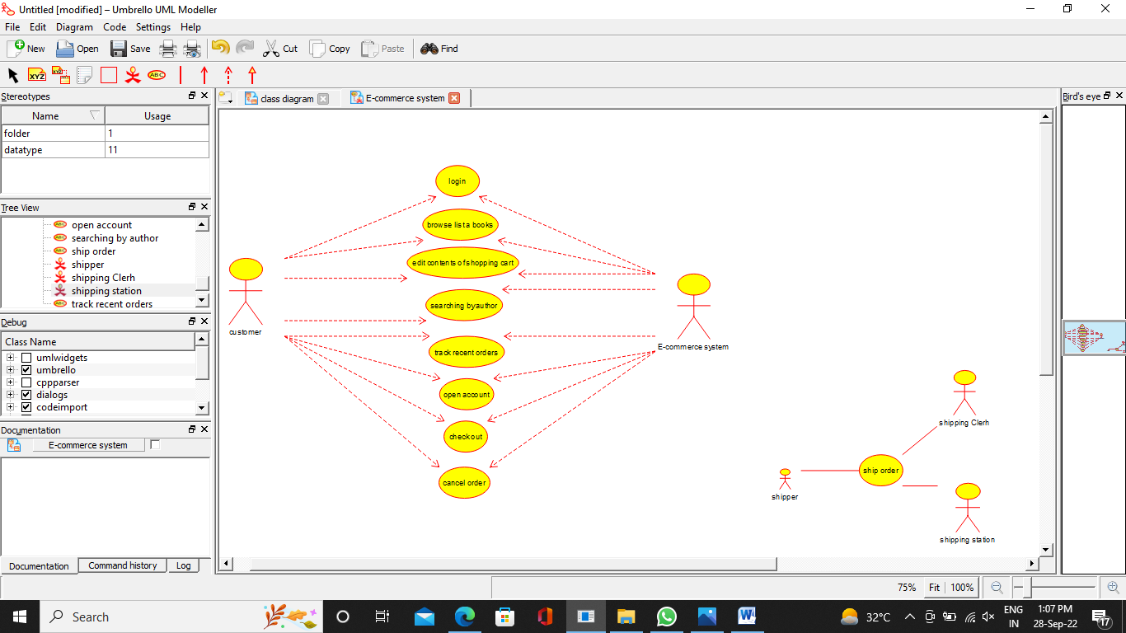

**2) CLASS DIAGRAM**

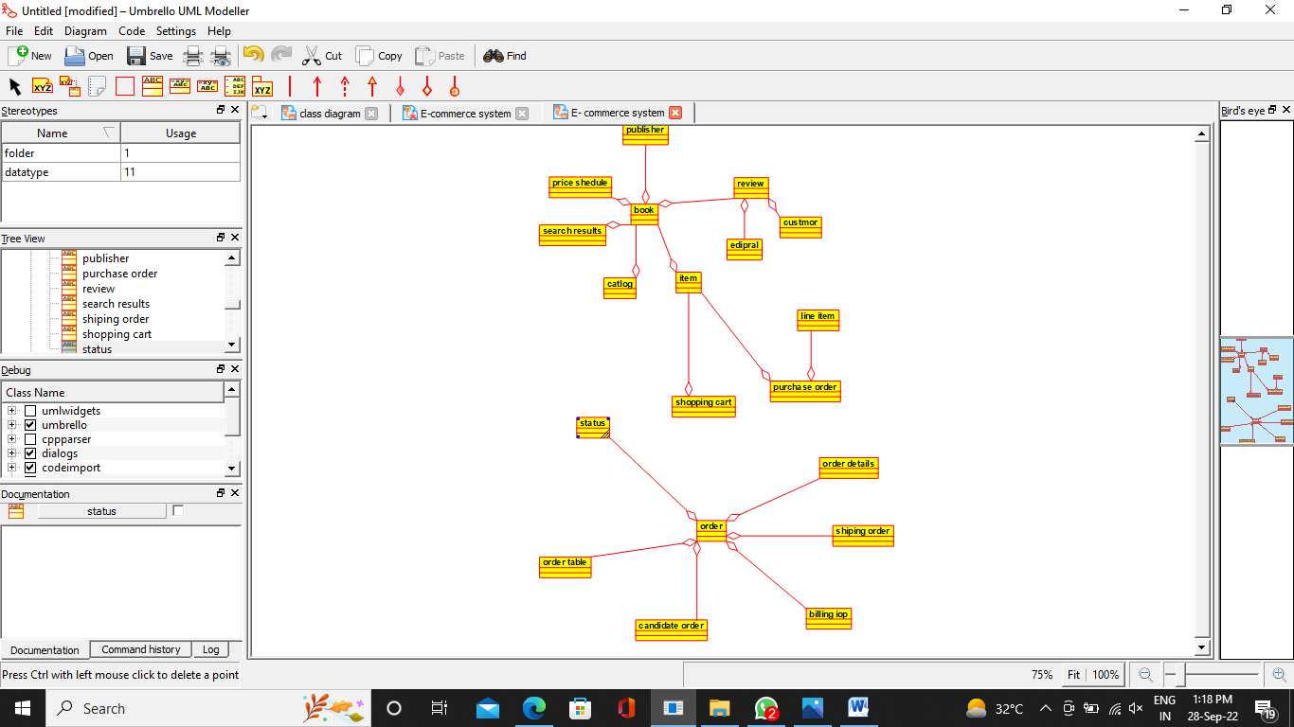

**3) ACTIVITY DIAGRAM**

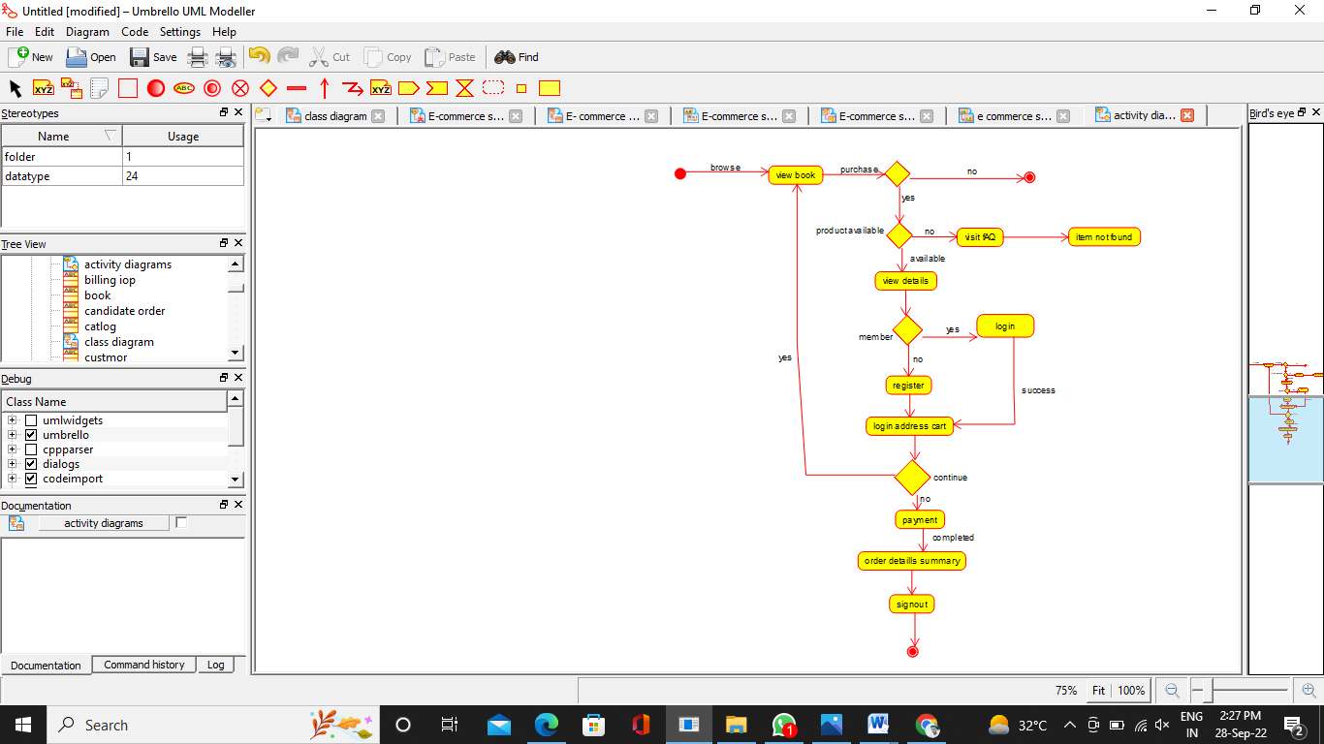

**4) SEQUENCE DIAGRAM**

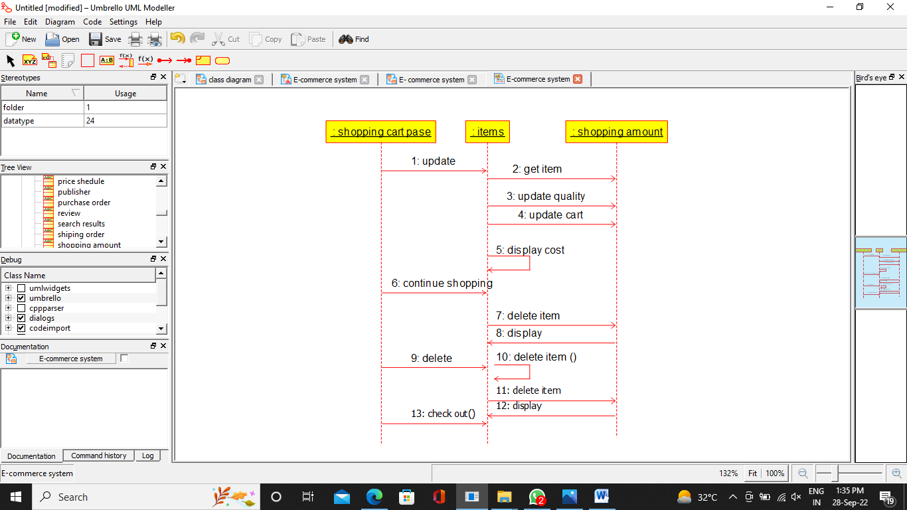

**5) COLLABORATION DIAGRAM**

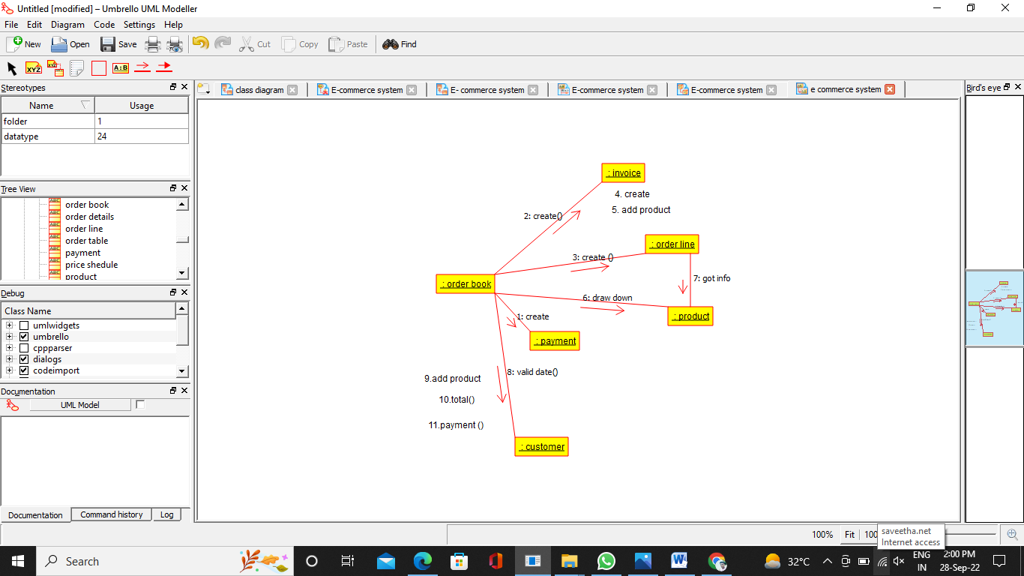

**6) COMPONENT DIAGRAM**

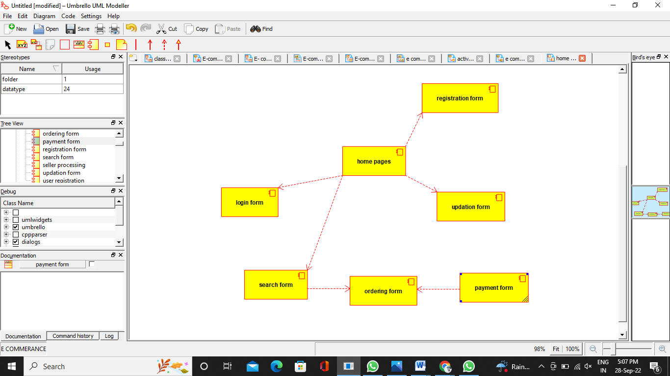

**7) DEPLOYMENT DIAGRAM**

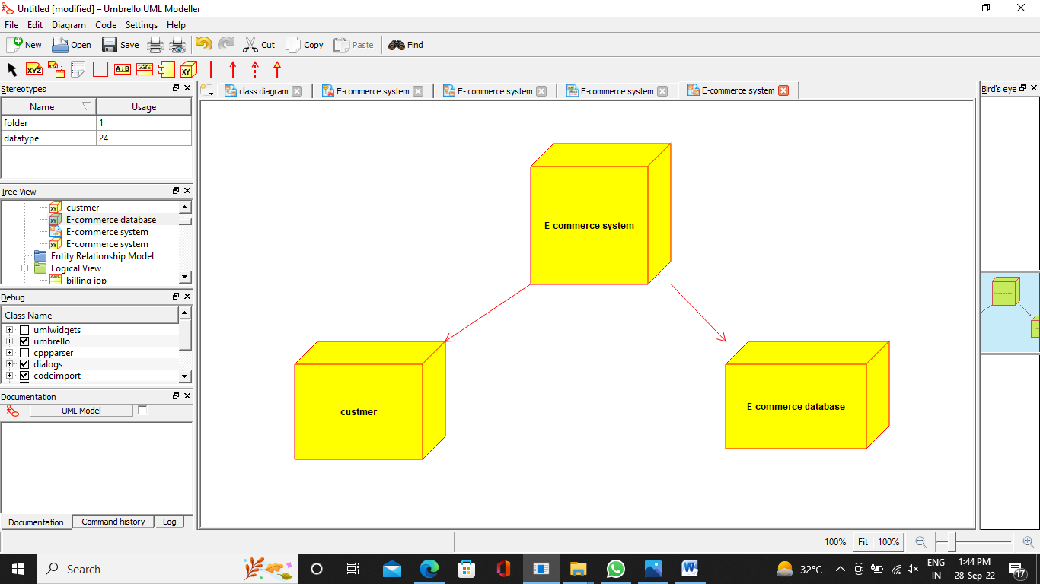

***PROGRAM CODING:***

**import java.util.*;**

**/\*\***

**\* Class book**

**\*/**

**public class book {**

**//**

**// Fields**

**//**

**//**

**// Constructors**

**//**

**public book () { };**

**//**

**// Methods**

**//**

**//**

**// Accessor methods**

**//**

**//**

**// Other methods**

**//**

**}**

**import java.util.*;**

**/\*\***

**\* Class publisher**

**\*/**

**public class publisher {**

**//**

**// Fields**

**//**

**//**

**// Constructors**

**//**

**public publisher () { };**

**//**

**// Methods**

**// Accessor methods**

**//**

**//**

**// Other methods**

**//**

**}**

**import java.util.*;**

**/\*\***

**\* Class shiping_order**

**\*/**

**public class shiping_order {**

**//**

**// Fields**

**//**

**//**

**// Constructors**

**//**

**public shiping_order () { };**

**//**

**// Methods**

**//**

**//**

**// Accessor methods**

**//**

**//**

**// Other methods**

**//**

**}**

**import java.util.*;**

**/\*\***

**\* Class shopping_cart**

**\*/**

**public class shopping_cart {**

**//**

**// Fields**

**//**

**//**

**// Constructors**

**//**

**public shopping_cart () { };**

**//**

**// Methods**

**//**

**// Accessor methods**

**//**

**//**

**// Other methods**

**//**

**}**